**1.What is ORM?**

The ORM is document which contains rules , regulations and guide lines for mapping object oriented Data model to Relational Data model. That means it is responsible for storing the Object Model data into Relational Model and for reading data from Relational Model to Object Model.

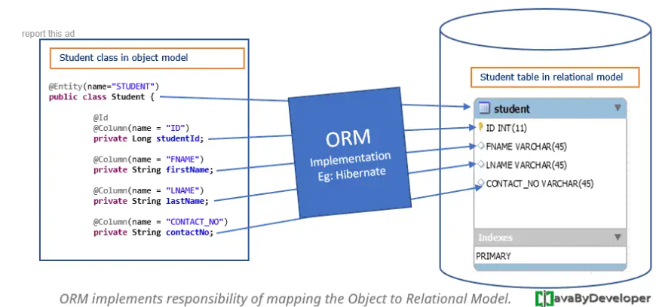

The third party vendors implements ORM document as tool. The Java related ORM tools are

1. Hibernate.
2. JPA
3. Open JPA
4. TopLink
5. EJB
6. …etc.

The ORM doing the mapping between Object oriented Data model element and Relational Data model elements . The elements are

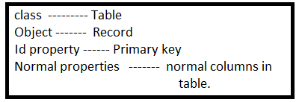

These mapping details are informed to ORM through XML file entries or annotations.

2.Need Of ORM(Object Relational Mapping):-

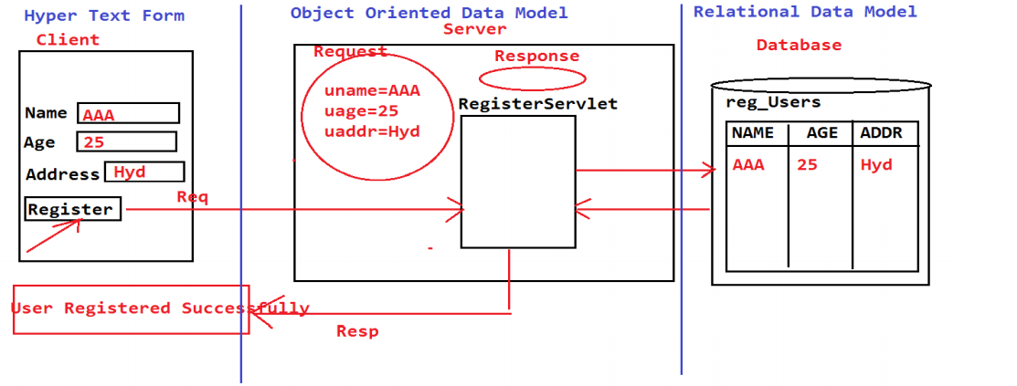

The Data which came from client is represented in object oriented Data model by underlying Server(Tomcat,GlashFish..etc). In Object oriented Data model , Data is in the form of object.

Every Data Model have own rules, regulations and guidelines to represent the data. Between The object oriented Data model and Relational Data model , There are differences in terms of rules, regulations and guidelines. Although differences exists, we can achieve the Data persistency but the level of persistence will be low.

The rules , regulations and guidelines gave some mismatches between Object oriented Data Model and Relational Data Model. The mismatches are

1. Granularity Mis-match.
2. Sub-type Mis-match
3. Associations Mis-match
4. Identity Mis-match
5. … etc

To improve the persistency and To resolve the mismatches , we need implementation of “ORM(Object Relational Mapping)”.